

**Covid Data Analysis On Databricks Using SQL**

* 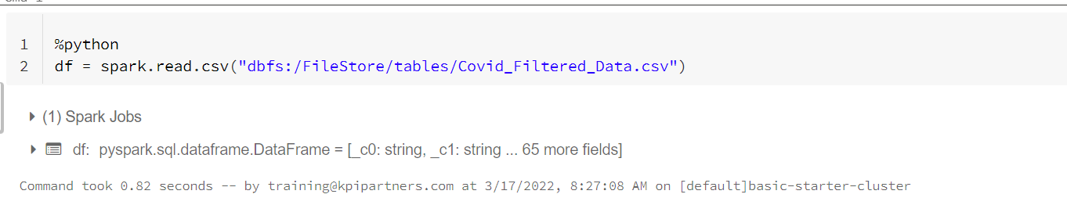Read required file
* Create a temp view

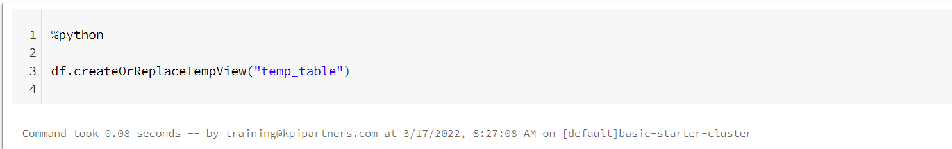

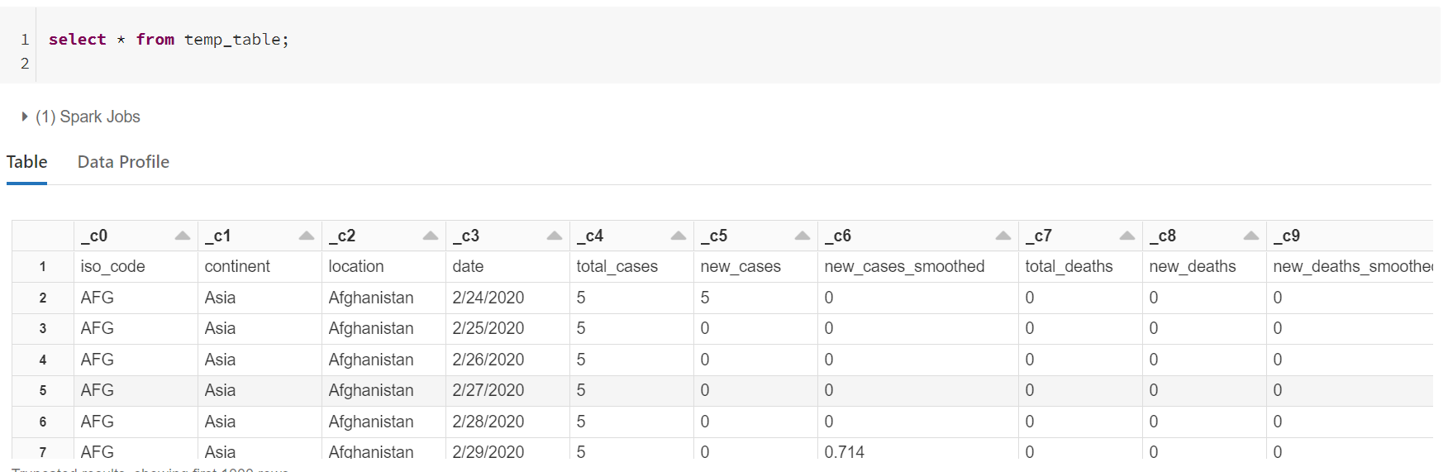

* 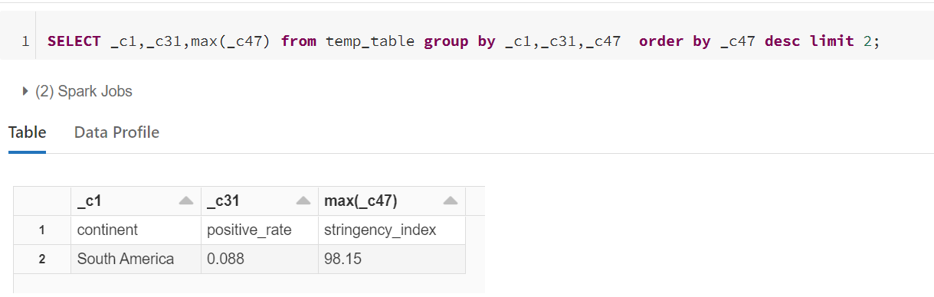Display the continent, positivity rate where the stringency index is maximum
* Which continent and location having maximum number of deaths and male smokers

